**PROJECT REPORT ON DATABASE MANAGEMENT**

**E-WALLET WEB APPLICATION**

SUBMITTED TO THE SAVITRIBAI PHULE PUNE UNIVERSITY, PUNE

SUBMITTED BY

|  |  |
| --- | --- |
| SHINDE SHUBHAM | Roll No: 145 |
| WAGH AKSHAY | Roll No: 150 |
| ANUJ JAIN | Roll No: 163 |
| BOTHARA PRATIKSHA | Roll No: 164 |
|  |  |



## DEPARTMENT OF COMPUTER ENGINEERING

## STES’S SMT. KASHIBAINAVALECOLLEGE OF ENGINEERING

**VADGAON BK, OFF SINHGAD ROAD, PUNE 411041**

## SAVITRIBAI PHULE PUNE UNIVERSITY

## 2017 - 18



**CERTIFICATE**

This is to certify that the project report entitles

**“E-WALLET”**

Submitted by

**NAME: SHINDE SHUBHAM Exam No:**

**NAME: WAGH AKSHAY Exam No:**

**NAME: ANUJ JAIN Exam No:**

**NAME: BOTHARA PRATIKSHA Exam No:**

is a bonafide work carried out by him/her under the supervision of **Prof. PRAMOD PATIL** and it is approved for the partial fulfillment of the requirement of University of Pune as a part of Database Management Lab work syllabus (Third year Computer Engineering).

|  |  |
| --- | --- |
| **(Prof. Pramod Patil)** | **(Dr. P. N. Mahalle)** |
| Department of Computer Engineering | Head, Department of Computer Engineering |

**ACKNOWLEDGEMENT**

I am grateful to SMT KASHIBAI NAVALE COLLEGE OF ENGINEERING PUNE for giving us an opportunity to develop this project and with an esteemed organisation.

I take this opportunity to acknowledge the support and continuous cooperation of all the people whose help was of unparalleled importance in making this project a success*.* I would like to express my gratitude towards my project mentor, Mr. PRAMOD PATIL (Asst. Prof. DATABASE MANAGEMENT SYSTEM LAB) who encouraged and supported us by giving continuous guidance, which kept us motivated throughout the project.

I owe my deep gratitude to our project guide to Ms. MANISHA PATIL, who took keen interest on our project work and guided us all along, till the completion of our project work by providing all the necessary information for developing a good system.

I would not forget to remember Mr. SANJAY PINGAT, for their encouragement and more over for their timely support and guidance till the completion of our project work.

I would be failing in my duty if I do not acknowledge, with a deep sense of

gratitude, the sacrifices made by my parents for allowing and supporting us to spend time on this project work and have helped us in completing the project work successfully.

I am thankful to and fortunate enough to get constant encouragement, support and guidance from all Teaching staffs of computer department which helped us in successfully completing our project work. Also, I would like to extend our sincere esteems to all staff in laboratory for their timely support.

NAME OF THE STUDENT

SHUBHAM SHINDE

AKSHAY WAGH

ANUJ JAIN

PRATIKSHA BOTHARA

**ABSTRACT**

E-commerce in today's conditions has the highest dependence on network infrastructure of banking. However, when the possibility of communicating with the Banking network is not provided, business activities will suffer. This paper proposes a new approach of digital wallet based on mobile devices without the need to exchange physical money or communicate with banking network. A digital wallet is a software component that allows a user to make an electronic payment in cash (such as a credit card or a digital coin), and hides the low-level details of executing the payment protocol that is used to make the payment. The main features of proposed architecture are secure awareness, fault tolerance, and infrastructure-less protocol.

**CONTENTS**

**LIST OF ABBREVATIONS I**

**LIST OF FIGURES II**

**LIST OF TABLES III**

|  |  |  |  |
| --- | --- | --- | --- |
| **CHAPTER** | | **TITLE** | **PAGE NO** |
| **01** | | Problem Definition |  |
| **02** | | Software Requirements Specification |  |
|  | **2.1** | **Introduction** |  |
|  | **2.2** | **Scope** |  |
|  | **2.3** | **Requirements** |  |
| **03** | | **Relational database design (ER & schema Diagram)** |  |
| **04** | | **Database normalization** |  |
| **05** | | GUI |  |
| **06** | | **Test cases with results** |  |
| **07** | | Conclusion |  |
| **08** | | References |  |

**LIST OF ABBREVATIONS**

|  |  |
| --- | --- |
| **Abbreviation** | **Illustration** |
| DBMS  ER DIAGRAM  MYSQL  RDBMS  HTML  PHP  DDL  DML  CSS  DNS  IP  PK | Database Management  Entity Relation  My Structured Query Language  Relational Database Management System  Hyper Text Markup Language  Hypertext Preprocessor  Data Definition Language  Data Manipulation Language  Cascaded Style Sheets  Domain Name System  Internet Protocol  Primary Key |
|  |  |
|  |  |
|  |  |
|  |  |
|  |  |
|  |  |
|  |  |
|  |  |

**LIST OF FIGURES**

|  |  |  |
| --- | --- | --- |
| **Figure** | **Illustration** | **Page No.** |
| 1.1 | ER Diagram | 12 |
| 1.2 | Schema Diagram | 13 |
|  |  |  |

**LIST OF TABLES**

|  |  |
| --- | --- |
| **sr. no.**  1  2  3  4 | **table name**  user_info  user_credentials  balance  passbook |

**problem definition**

Create a website for E-Wallet using suitable Front-End Language and Database. The user should be able to create account, add money to his/her account and send money to other accounts. The user should also be able to edit his/her profile. The user should also be able to view his/her transaction history. The user should also be able to reset password. Use appropriate validations in forms. Also display error messages for incorrect input.

**SOFTWARE REQUIREMENT SPECIFICATION**

**INTRODUCTION**

Nowadays with the growing numbers of credit cards such as Visa, Master card, that people use on a daily basis. It is very demanding to find a way to transfer money easily. Therefore, there is a solution which is E wallet software. E wallet software is software providing an easy access to the numerous transactions with safety guaranteed. All information can be safely locked inside E-wallet software files with a single password.

This paper presents a project that we have done. This project explains how to develop a software for the E - wallet in terms of project management. This project involves the five project management phases to complete the project successfully. The five phases are initiation, planning, execution, monitoring and the closing phase.

**SCOPE**

Project Justification:

The goal is to develop an E-wallet program that can be used electronically on any individual device. This will enable users to save all their cards data on their device and obsolete the use of the physical cards in matter of more easy and secure use till this moment

Product Characteristics and Requirements:

1. A Head Team will find the best programing language, web server, database, and internet provider to meet the project requirements.

2. The Head Team will create three teams: Development team, testing team, and training team.

3. A user friendly GUI to meet the targeted customers (age range from 21 to 60 years old).

4. The development has to create a staple code for the program and be installable on the most useable platforms in the market.

5. The testing has to make sure that there aren’t any bugs or exactions in the code before the final release.

6. The training team has to train the retailers on the new product and offer all the help if needed.

7. A promotional campaign will introduce the software especially in the internet world.

**REQUIREMENTS**

Operating system : Windows

Front end : PHP, CSS, HTML

Platform : XMAPP Control Panel

Back end : MySQL

**RELATIONAL DATABASE DIAGRAMS**

1. 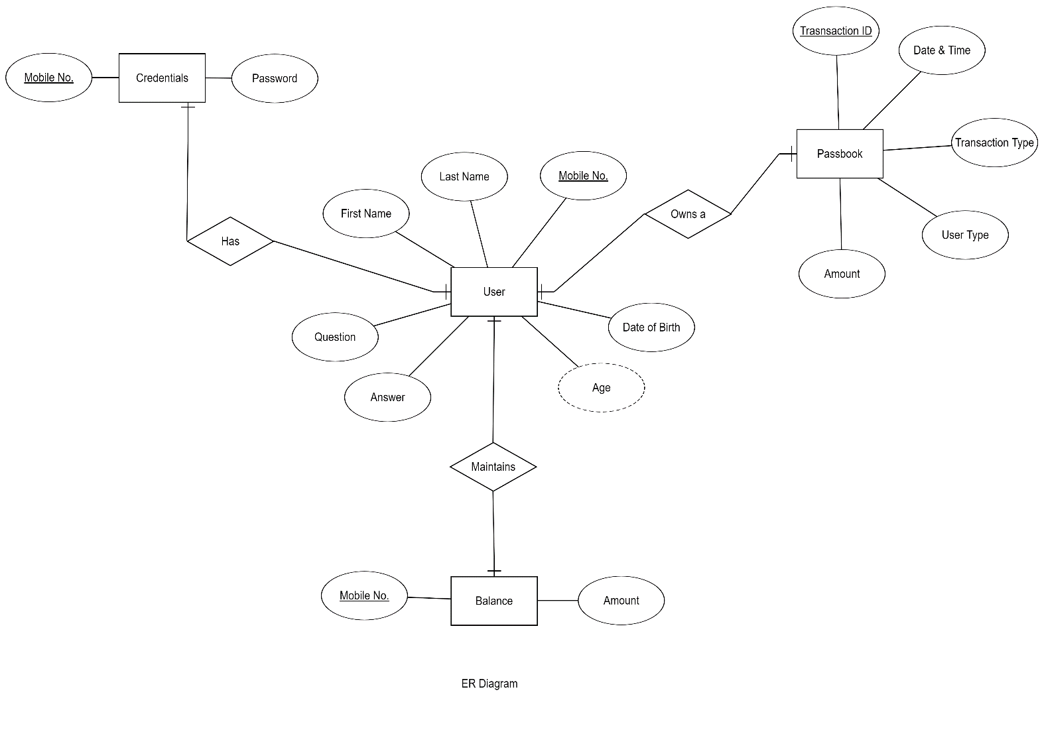**ER DIAGRAM**
2. **SCHEMA DIAGRAM**

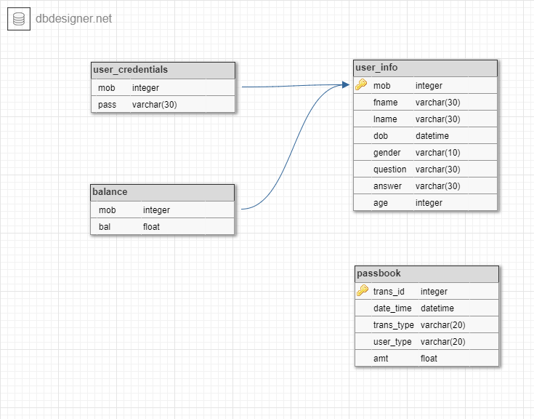**GUI**

1. Login



1. Signup

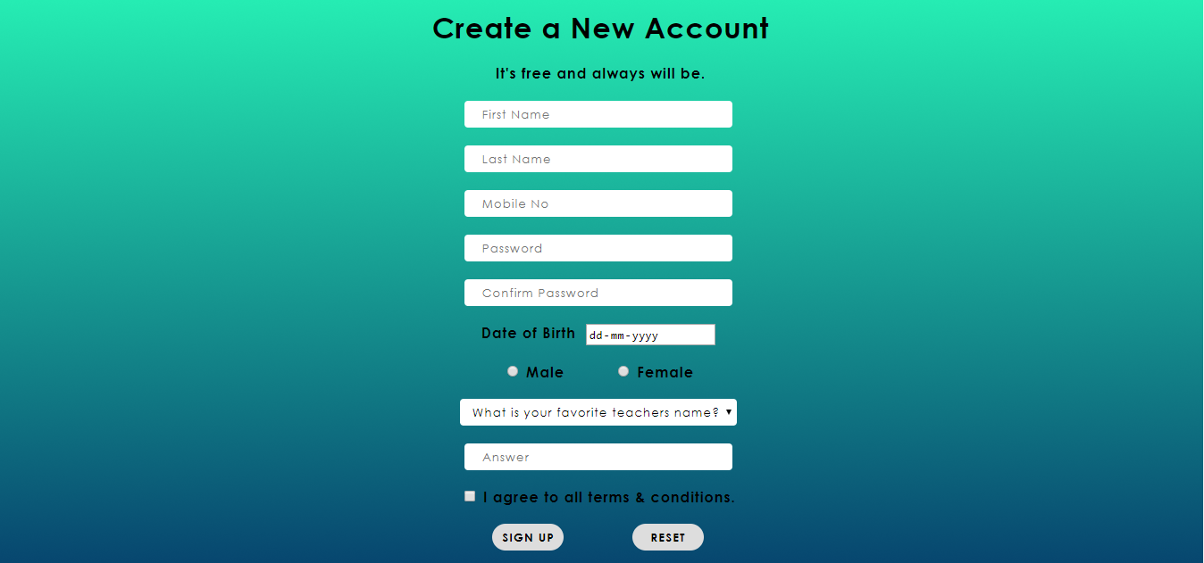

1. Welcome Screen

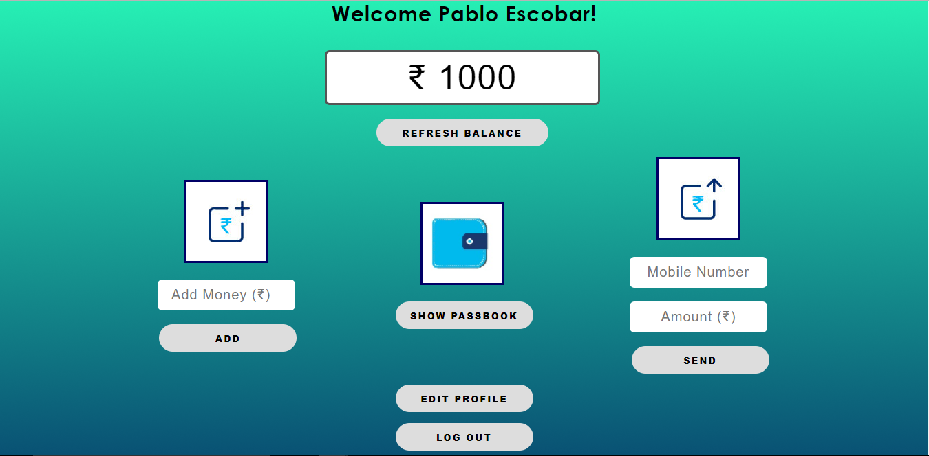

1. Profile

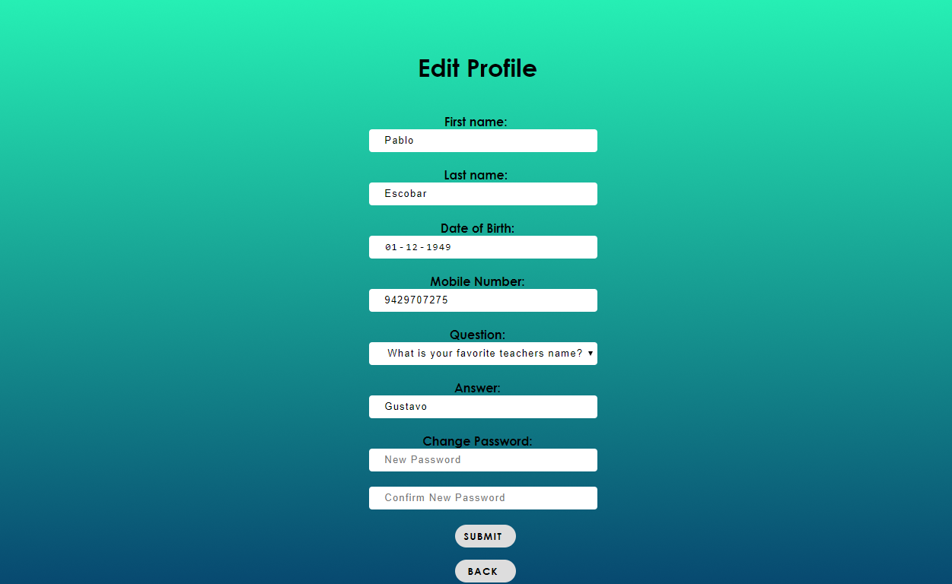

1. Passbook

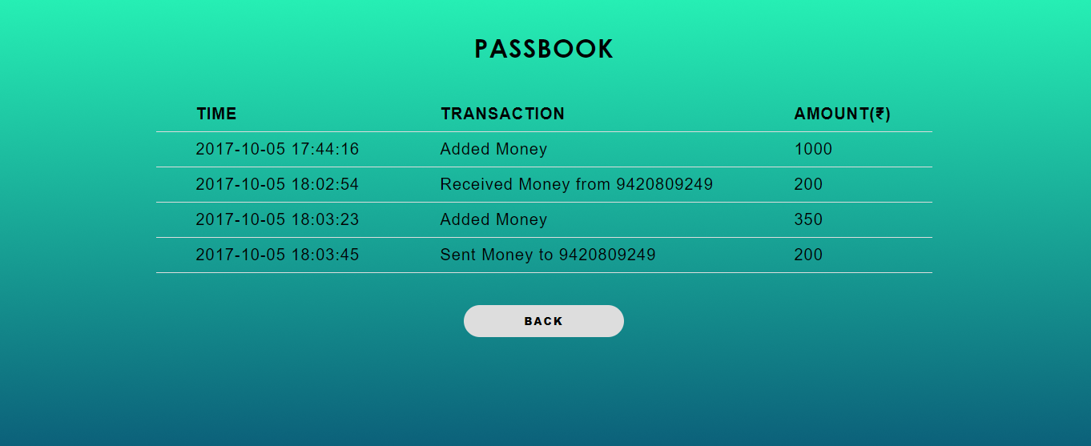

1. Forgot Password

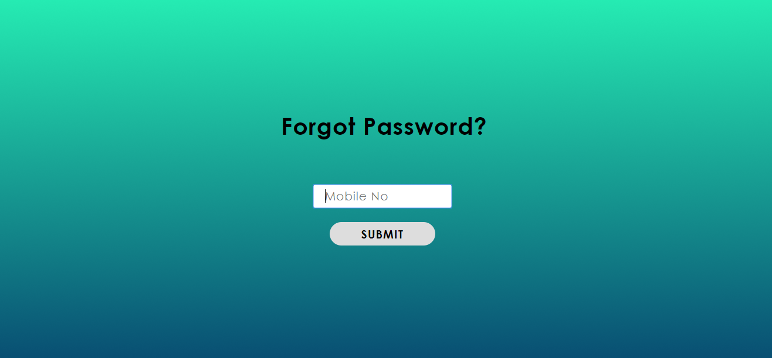

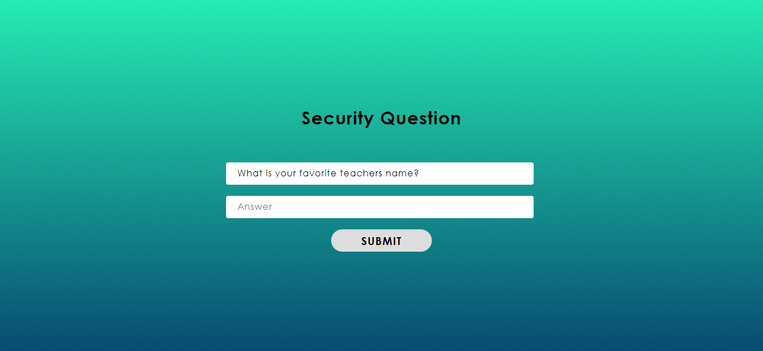

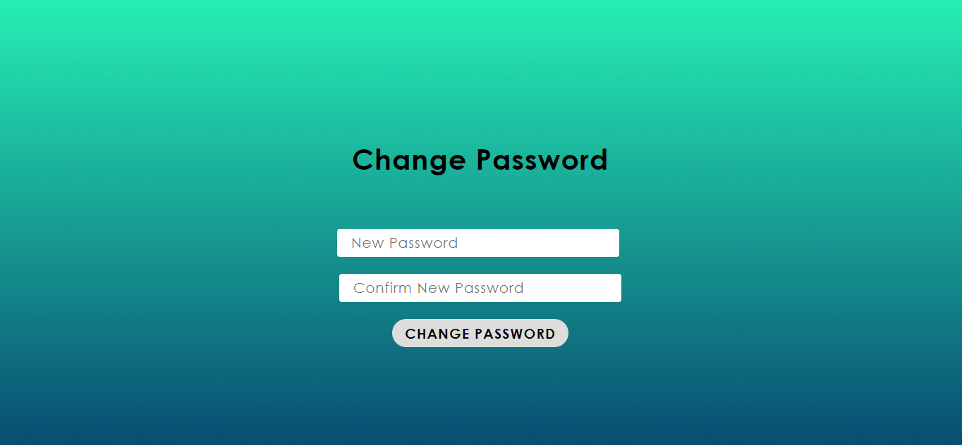

**TEST CASES WITH RESULTS**

1. User doesn’t exist

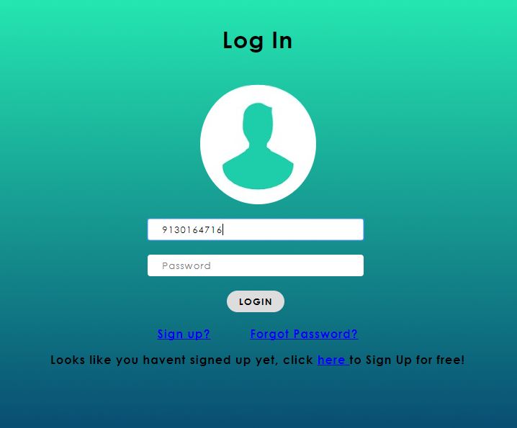

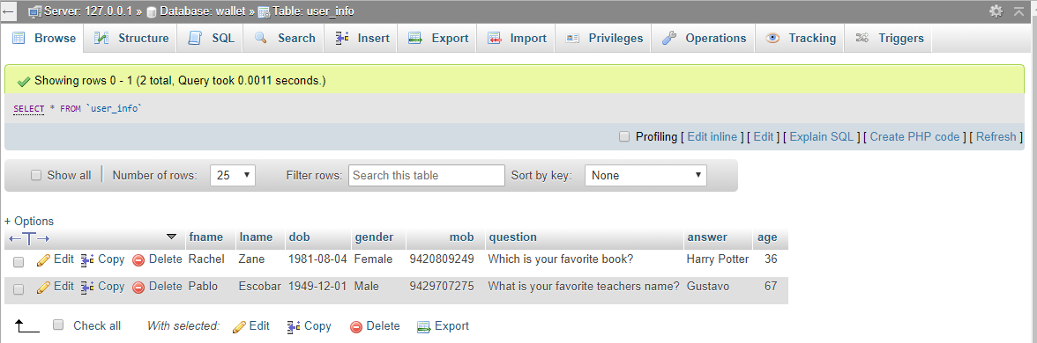

1. Invalid mobile number / password

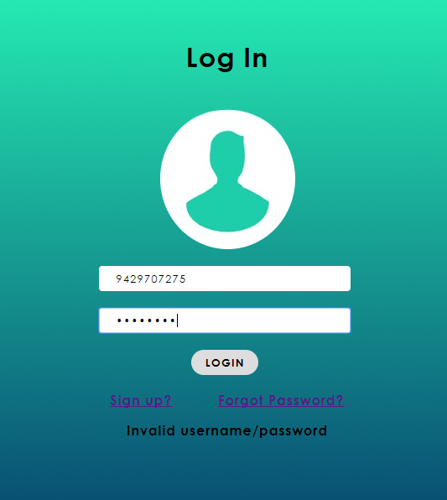

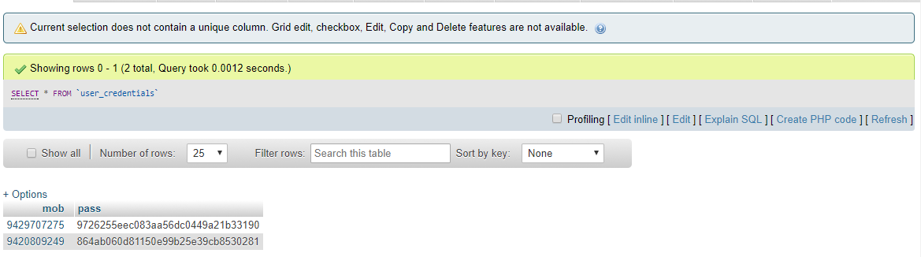

1. Insufficient Balance

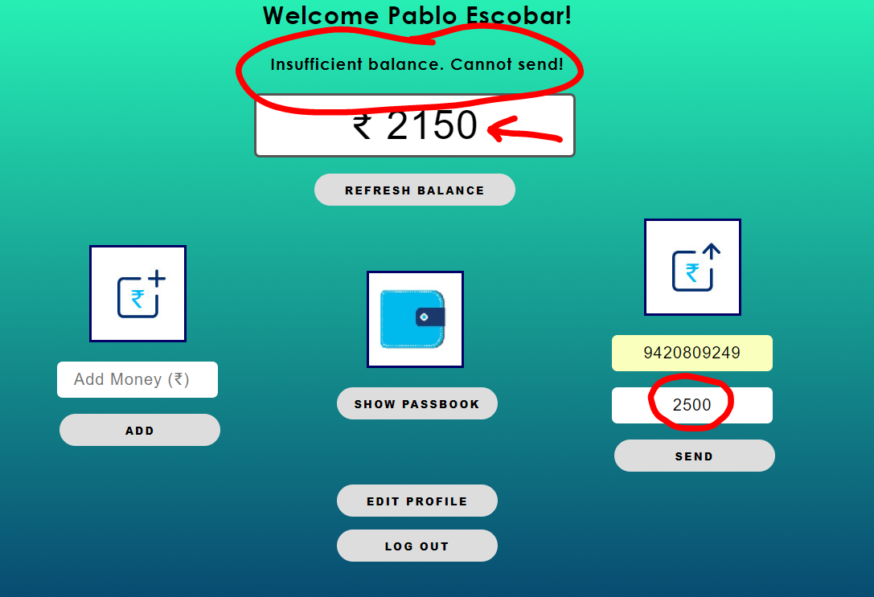

1. Minimum amount to add

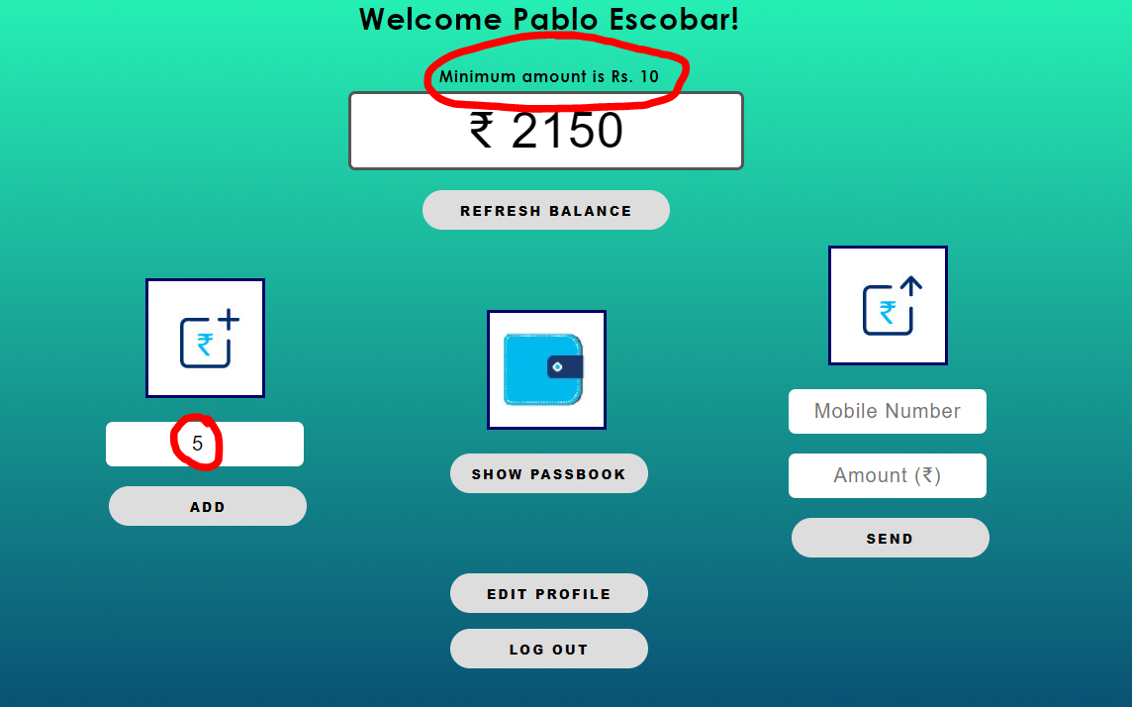

1. Security answer validation

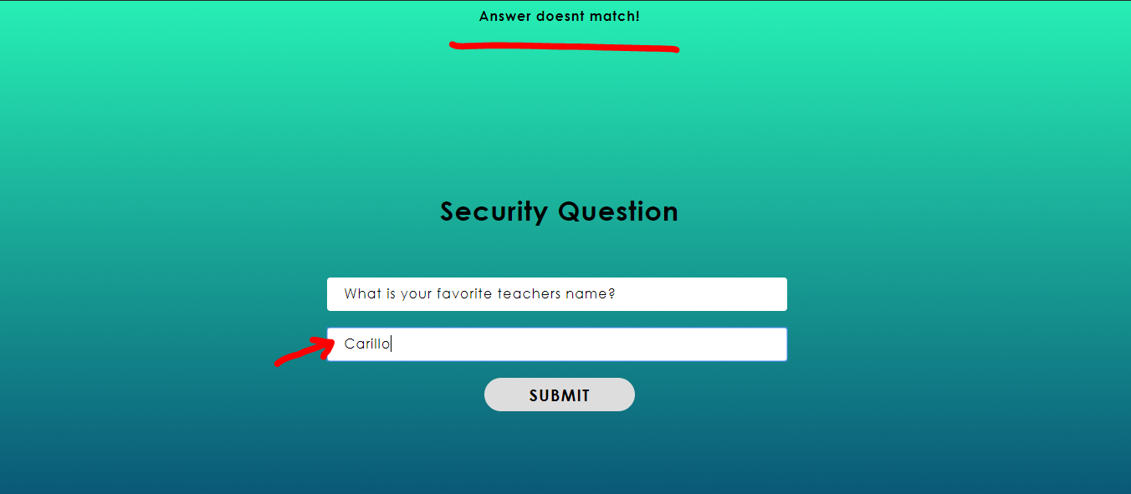

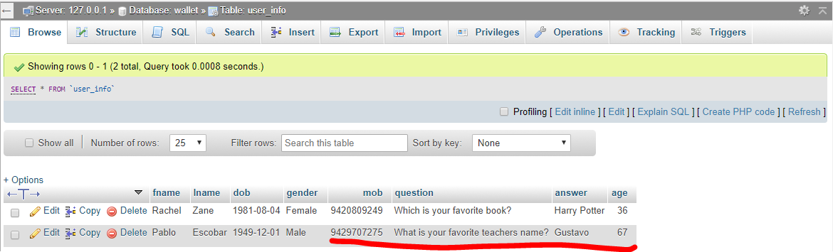

1. Required field

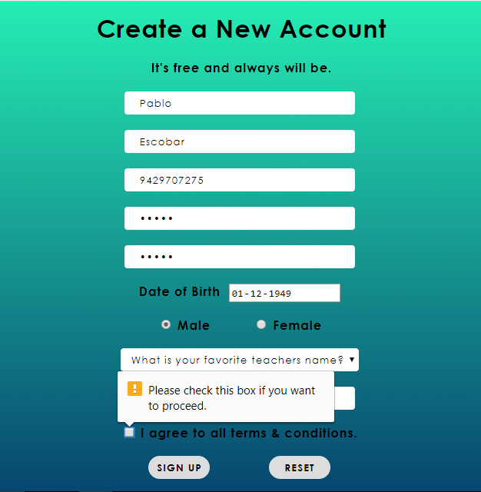

**CONCLUSION**

In this paper, we presented the design of architecture of Digital Wallet. Proposed solution is encryption software that works like a physical wallet during electronic commerce transactions. It can hold a user's payment information, a digital certification to identify the user, and shipping information to speed transactions.

The consumer benefits because his or her information is encrypted against piracy and because some wallets will automatically input shipping information at the merchant's node and will give the consumer the advantage of using digital money.

**references**

**BOOKS:**

**1.** C J Date, “An Introduction to Database Systems”, Addison-Wesley, ISBN: 0201144719

**2.** S.K.Singh, “Database Systems : Concepts, Design and Application”, Pearson, Education, ISBN 978-81-317-6092-5

**3.** Kristina Chodorow, Michael Dirolf, “MangoDB: The Definitive Guide” ,O’Reilly Publications, ISBN: 978-1-449-34468-9.

**4.** Adam Fowler, “NoSQL For Dummies”, John Wiley & Sons, ISBN-1118905628

**5.** Kevin Roebuck, “Storing and Managing Big Data - NoSQL, HADOOP and More”, Emereopty Limited, ISBN: 1743045743, 9781743045749

**6.** Joy A. Kreibich, “Using SQLite”, O'REILLY, ISBN: 13:978-93-5110-934-1

**7.** Garrett Grolemund, “Hands-on Programming with R”, O'REILLY, ISBN : 13:978-93-5110-728-6

**WEBSITES:**

1. <https://www.w3schools.com/>
2. <https://stackoverflow.com/>
3. <https://www.youtube.com/user/thenewboston>
4. <https://erdplus.com/>
5. <http://php.net/docs.php>